# CREATE A DATABASE IN CLOUDANT DB

|  |  |
| --- | --- |
| DATE | 19 NOVEMBER 2022 |
| TEAM ID | PNT2022TMID13705 |
| PROJECT NAME | GAS LEAKAGE MONITORING AND ALERTING SYSTEM FOR INDUSTRIES |

**Create A Database In Cloudant DB.**

**Aim:** To create a database in Cloudant DB to store location data. Steps followed:

* Logged in to IBM Cloud account.
* Navigated to `./resources`.
* Clicked on the “Create Resource +” button.
* Searched for “Cloudant”.
* Chose the “Lite Version” and clicked on “Create”.

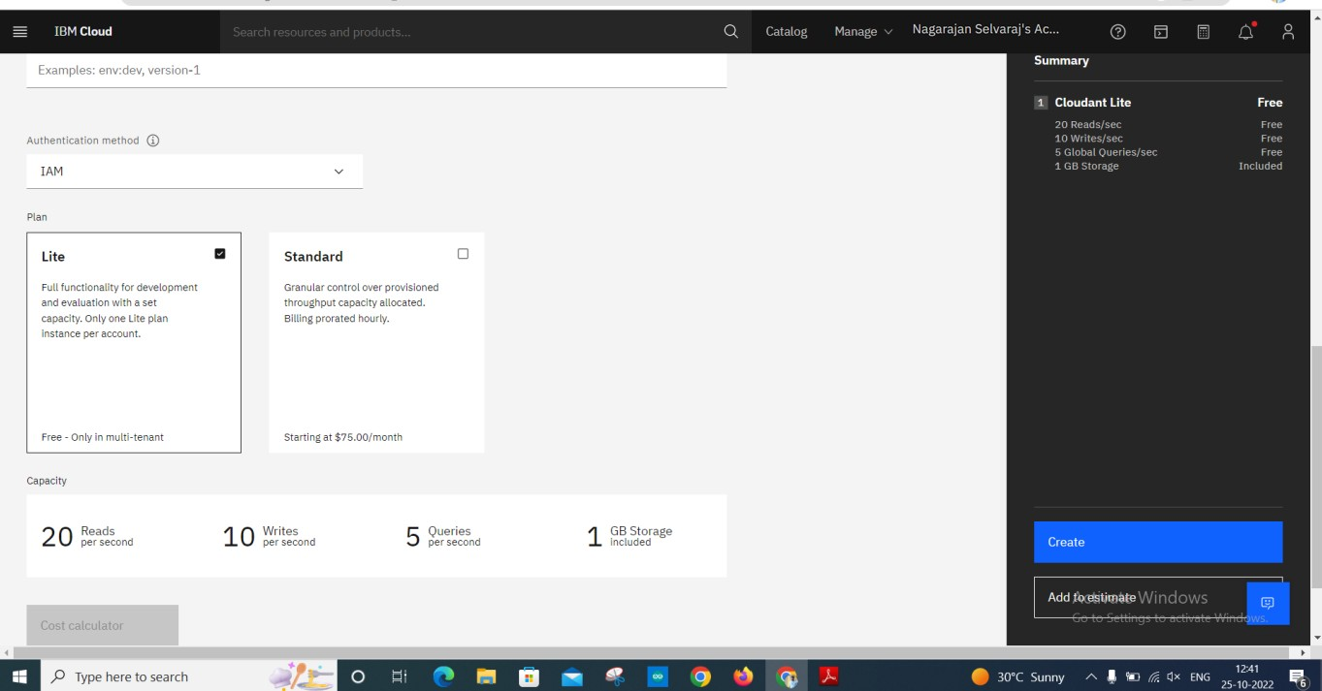

* The Cloudant database resource was created successfully

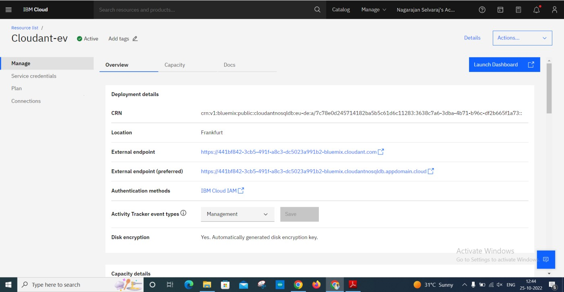

* Clicked on Launch Dashboard

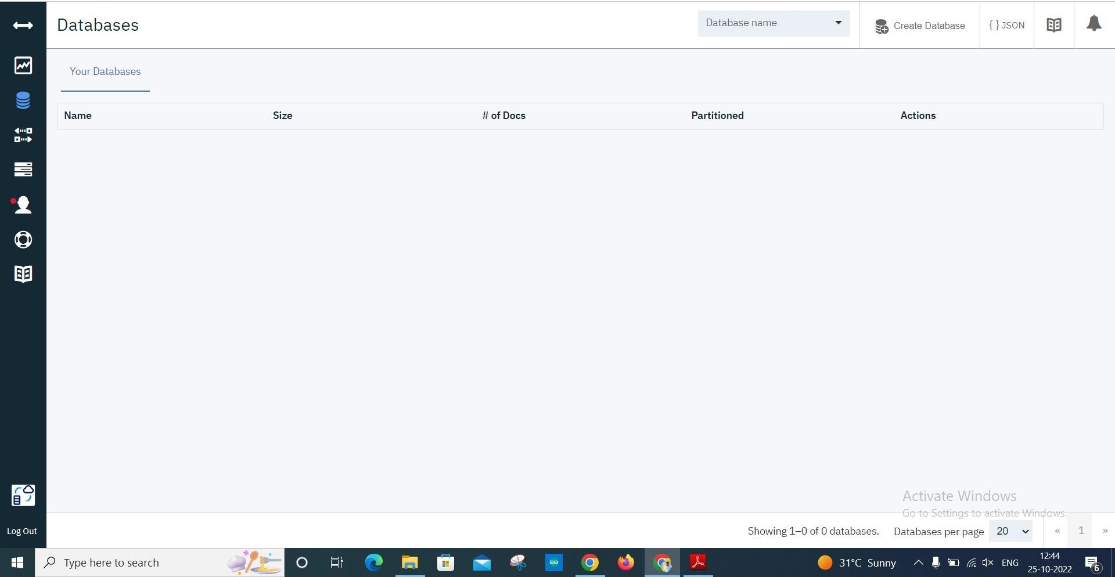

* Clicked on “Create Database”. Entered “meowman” as the database name and the “Non-partitioned” option.

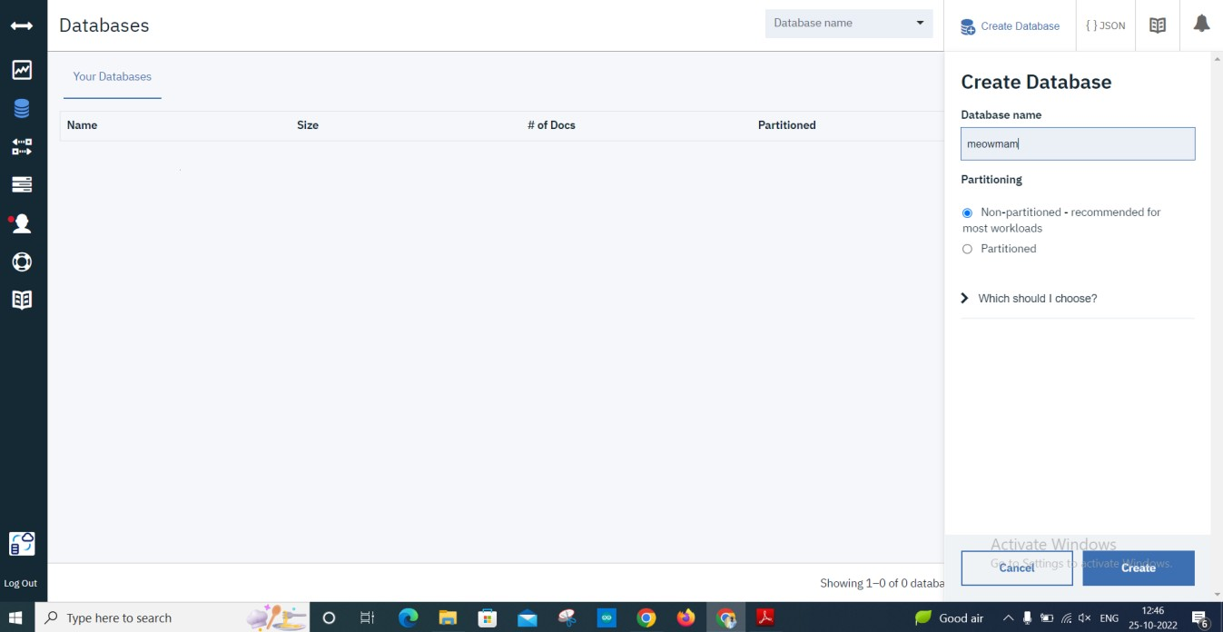

* The database “meowman” was created successfully.

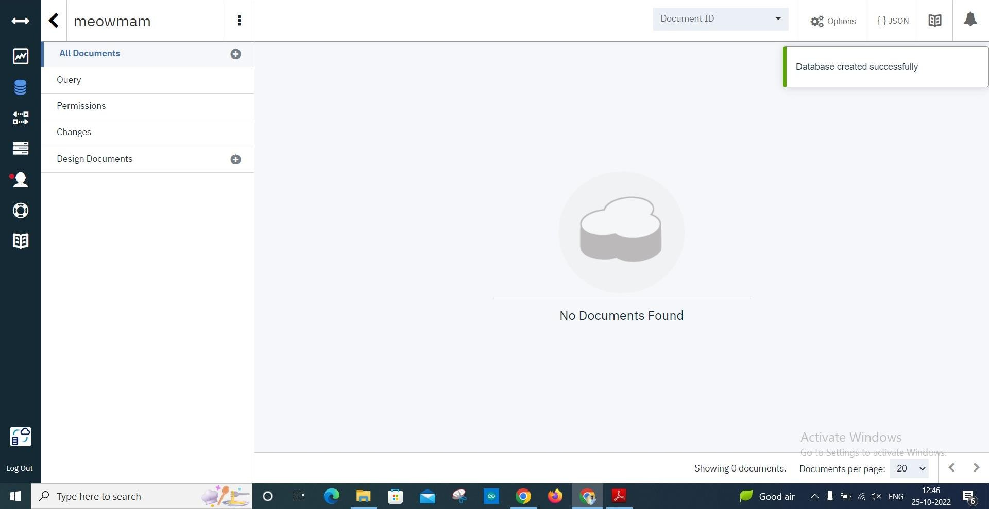

# Result:

A database to store the location data was created successfully on Cloudant DB.